**QSMART – INTEGRAGRATION OF AN EMPTY PUMP CHAMBER**

**PROCEDURE**

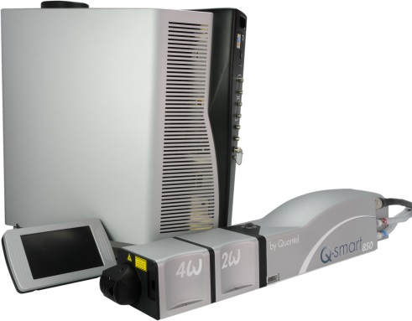

**Toolkit:**

Metric Allen key

Special tool RM100004

Target (at 43mm)

**System**: QSMART

|  |  |  |  |
| --- | --- | --- | --- |
| |  |  | | --- | --- | | **SM010341**  **SM010342**  **SM010343**  **SM010344** | **Q-SMART850 PUMP CH W OPT S/E**  **Q-SMART850 PUMP CH W/O OPT**  **Q-SMART850 ROD ASSY**  **Q-SMART850 ROD ASSY STD EXCH** | |  |

**Purpose**: This document details how to change the content of the pump chamber

|  |  |  |
| --- | --- | --- |
| Revision | date | modification |
| Initial issue | July 4, 2014 |  |
|  |  |  |
|  |  |  |
|  |  |  | |

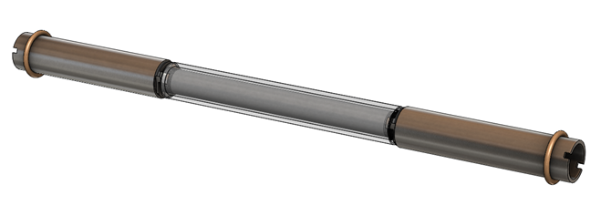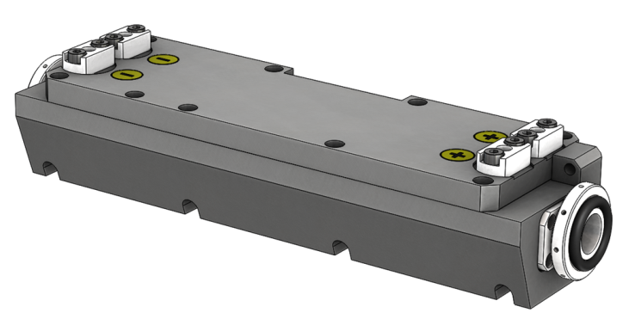

# ESTABLISHMENT OF Q-SMART850 ROD ASSY

|  |  |  |
| --- | --- | --- |
| 2.00 | 3/E10/0659 | O-Ring D15 C2 |
| 2.00 | 3/PLA/1238 | Rod retainer |
| 8.00 | V/CHC/M0306A4 | Screw CHC M3X6 |
| 1.00 | RM100004 | Special tool rm100004 |

# DISASSEMBLING

* At this step, the pump chamber is outside the Laser head.

(Refer to the procedure: “*LH – SM010340* *Pumping Chamber replacement*”

* Remove the flashlamp cover by unscrew (in a cross) the 8 screws.
* Remove all the mechanical parts which maintain the rod.
* Remove the rod.

# REASSEMBLING AND ALIGNMENT

* Put the rod assy and centered it inside the pump chamber.
* Add the two O-rings (3/E10/0659)
* Add the two rod retainer (3/PLA/1238) and the 8 screws CHC 3x8 without screwing completely the screws.

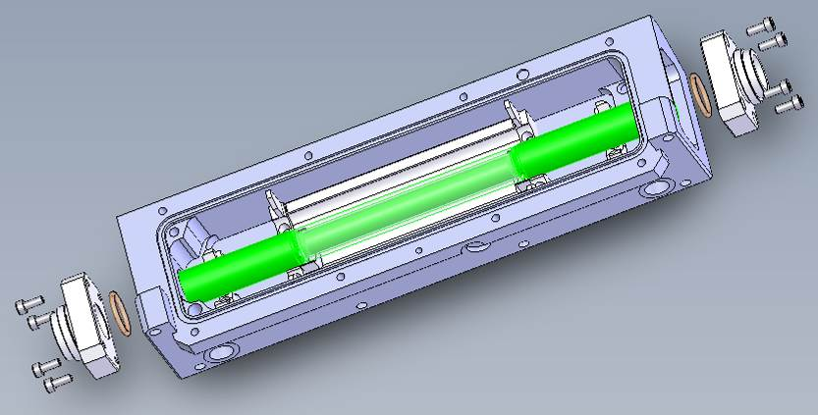

Check the good alignment of the He-Ne (height=43mm): the pin hole must be in place.

You have to check with a target near field (adjust M1) and far field (adjust M2)

M1

Pin hole

He-Ne

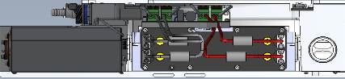



M2

Target

Install the pump chamber on the special tool RM100004. Install this two parts on the He-Ne way.

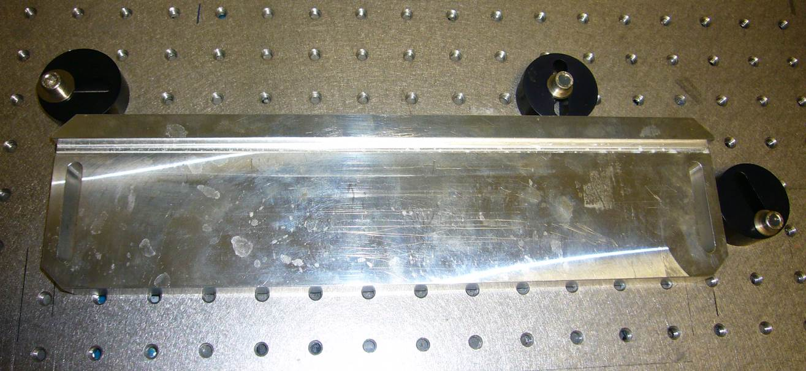

RM100004

Pumping chamber on his alignment tool (view of the top)

RM100004

HeNe incident ___________

HeNe reflected _ _ _ _ _ _ _ _

When the adjustment of the reflected beam is done, tight in cross the 4 screws of rod retainers (3/PLA/1299) on both side. Check, that the rod hasn’t move when you have finished to tight.

* **Reassembly of the pump chamber**

|  |  |  |
| --- | --- | --- |
| 1.00 | 3/E10/0667 | O-Ring D153 C2 |
| 2.00 | 3/PLA/1299 | SEALING DUST RING |
| 2.00 | 3/ATC/0010 | Cover label + |
| 2.00 | 3/ATC/0013 | Cover label - |
| 1.00 | 3/ATC/0121 | Cover label HT |
| 8.00 | V/CHC/M0410A4 | Screws CHC M4x10 |

Place the flashlamp cover and screw in the indicated order the 8 screws (CHC 4x10)

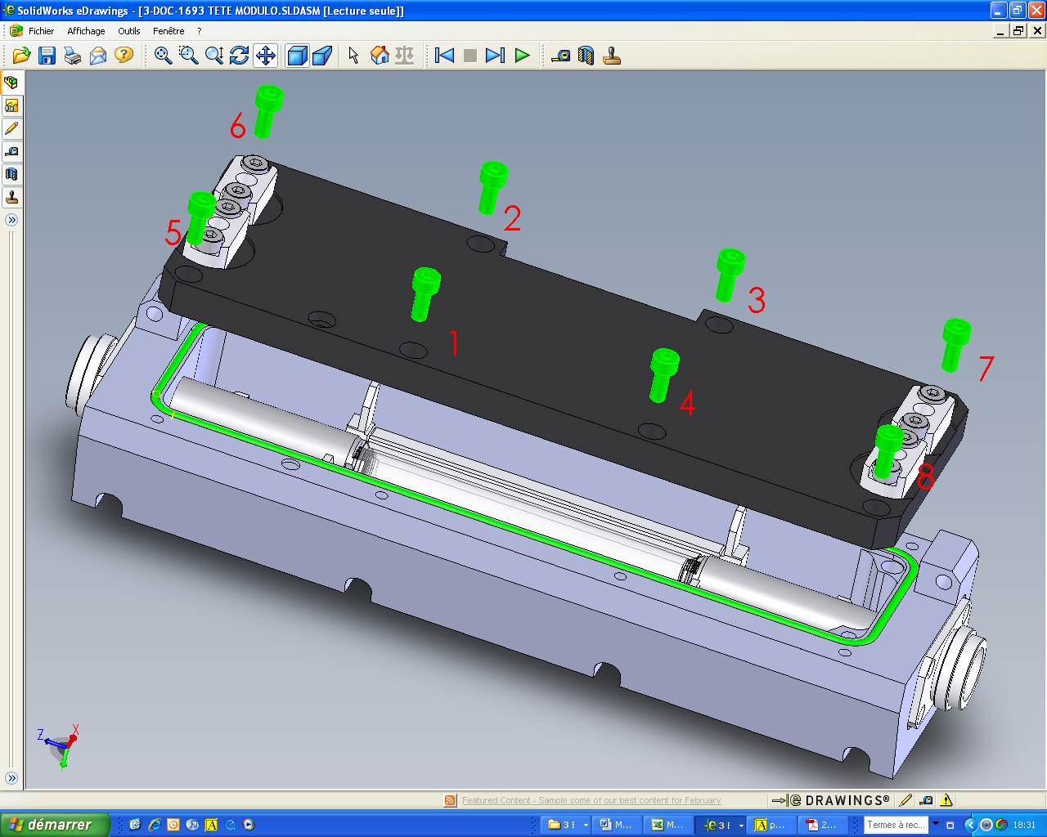

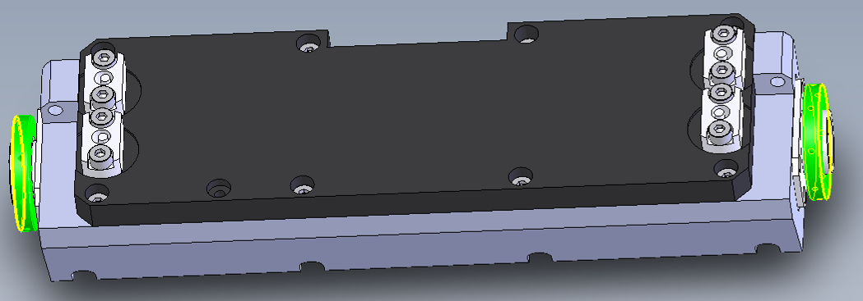Install and screw the 2 sealing dust ring (3/PLA/1229), and add the 2 Orings.